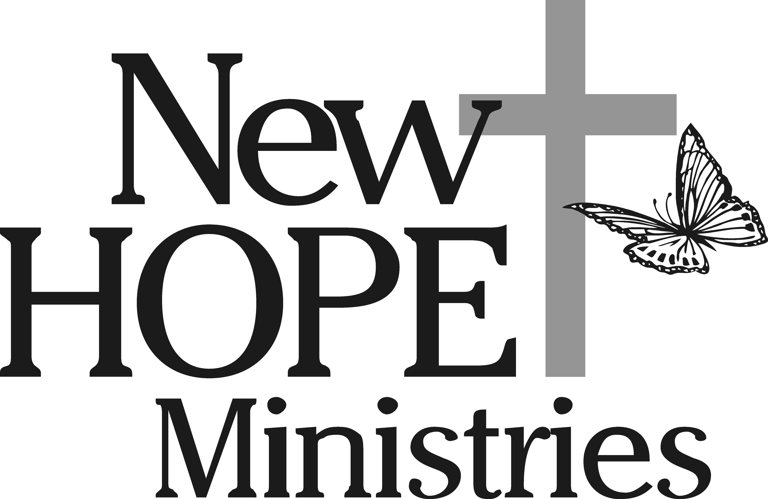

New Hope Ministries Statement of Faith

The incorporators of New Hope Ministries believe the Bible to be the inspired, infallible, authoritative Word of God, and in seeking to live in obedience to the truth and teaching found in the Bible, have incorporated New Hope Ministries to provide a service to minister to the physical and spiritual needs of others.

It is the intent of the incorporators of New Hope Ministries that the services and programs provided extend the message of Hope found in the witness of God’s love through the redemptive work of the Lord Jesus Christ.

To ensure the continued focus on this original intent, the incorporators of New Hope Ministries are including in the By Laws the following Statement of Faith and Theological Rationale for the work of New Hope Ministries.

Statement of Faith

- We believe the Bible to be the inspired, the only infallible, authoritative Word of God.

- We believe that there is one God, eternally existent in three persons: Father, Son and Holy Spirit.

- We believe in the deity of our lord Jesus Christ, in His virgin birth, in His sinless life, in His miracles, in His vicarious and atoning death through His shed blood, in His bodily resurrection, in His ascension to the right hand of the Father, and in His personal return in power and glory.

- We believe that for the salvation of lost and sinful man, regeneration by the Holy Spirit is absolutely essential.

- We believe in the present ministry of the Holy Spirit by whose indwelling the Christian is enabled to live a godly life.

- We believe in the resurrection of both the saved and the lost; they that are saved into the resurrection of life and they that are lost unto the resurrection of damnation.

- We believe in the spiritual unity of believers in our Lord Jesus Christ.

In light of our belief in the Lord Jesus Christ and in obedience to His teachings, we submit the following rationale as a basis for the work of New Hope Ministries.

Theological Rationale

Matthew 25: 25-40 TEV. “I was hungry and you fed me, thirsty and you gave a drink; I was a stranger and you received me in you homes, naked and you clothed me; I was sick and you took care of me, in prison and you visited me.” The righteous will then answer him, “When, Lord, did we ever see you a stranger and welcome you into our homes, or naked and clothe you? When did we ever see you sick or in prison, and visit you?” The King will reply, “I tell you, whenever you did this for one of the least important of these brothers of mine, you did it for me!”

James 2: 12-18 NIV. What good is it, my brothers, if a man claims to have faith but has no deeds? Can such faith save him? Suppose a brother or sister is without clothes and daily food. If one of you says to him, “Go, I wish you well; keep warm and well fed,” but does nothing about his physical needs, what good is it? In the same way, faith by itself, if it is not accompanied by action, is dead.

But someone will say, “you have faith, I have deeds.”

Show me faith without deeds, and I will show you my faith by what I do.

I John 3: 16-18 NAS. We know love by this, that He laid down His life for us: and we ought to lay down our lives for the brethren. But whoever has the world’s goods, and beholds his brother in need and closes his heart against him, how does the love of God abide in him? Little children, let us not love with word or tongue, but in deed and truth.

I Corinthians 13: 3 JB. If I give away all that I possess, piece by piece, and if I even let them take my body to burn it, but am without love, it will do me no good whatever.

Galatians 5: 6b JB. …what matters is faith that makes its power felt through love.

Therefore, let it be understood that:

New Hope Ministries is a non-profit Christian social service for low and no income families of the York, Adams and Cumberland County areas. It is formed by concerned Christians to show the love of Christ through the meeting of human need.

