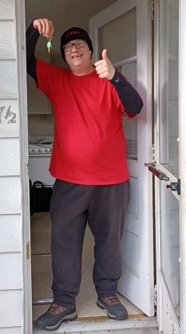
David was homeless and unemployed. Through the work of New Hope Ministries and the United Way of the Capital Region’s Road to Success program, we helped David get a job at Giant Foods as a Grocery Associate. The Road to Success program helped with transportation assistance to and from his job. Then, an apartment became available in a location convenient to his work. New Hope met with the realtor, and helped secure the security deposit and the Road to Success program helped with the first month’s rent. Together, we visited CommunityAid (another New Hope partner) where he found dishes and a coffee table for his new apartment. New Hope was able to provide David with a bed, kitchen table and chairs, and some additional household items. On moving day, several New Hope staff members helped David move into his new apartment – just in time for Christmas. He continues to work steadily and is enjoying living independently in his new place! Because of those who support New Hope Ministries’ programs that transform lives, we can help people just like David.

Need help? If you know someone needs help with food or dealing with a financial crisis, please contact us. (717) 432-2087
Wish list: Please see website for specific needs by Center: www.nhm-pa.org
We could use your help! Please prayerfully consider volunteering time at New Hope Ministries!
www.nhm-pa.org

