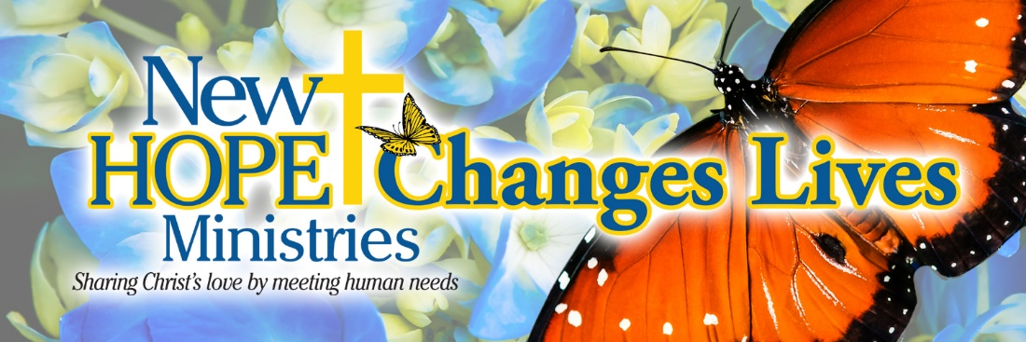

Meet Shauna, a single mom who experienced a traumatic physical injury a while back, which made it impossible for her to return to work. Over the years, we've built a great relationship with Shauna, and she always tells us that coming to New Hope feels like coming home. Recently, Shauna was able to get a beautiful new pair of sneakers from our Christmas Blessing Express program, and she also got an amazing outfit using a clothing care card. She feels so grateful to be able to take care of herself with a little help from New Hope, especially since her daughter always comes first. It's amazing to see how much of an impact we can make in someone's life with just a little bit of kindness and support. Shauna is pictured here on the right, standing with Center Manager Victoria.

May the God of hope fill you with all joy and peace as you trust in him, so that you may overflow with hope by the power of the Holy Spirit.
Romans 15:13

Need help? If you know someone needs help with food or dealing with a financial crisis, please contact us. (717) 432-2087
Wish list: Please see website for specific needs by Center: www.nhm-pa.org
We could use your help! Please prayerfully consider volunteering time at New Hope Ministries!
www.nhm-pa.org

