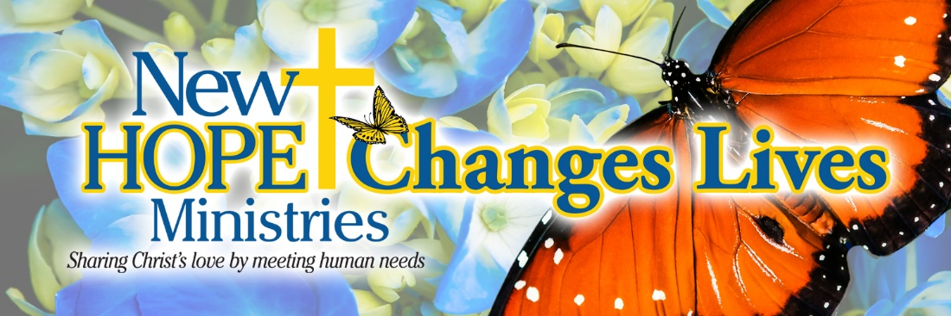

 A young father and his three children are celebrating a home of their own. His journey began at our Dillsburg Center, where he was referred to our homeless services program. With New Hope’s support, he applied for housing and was approved, just in time to move in on his daughter’s fourth birthday. This photo captures his visit to our Enola Center, where he was celebrated as he begins this new chapter. **Your support helps families move from crisis to stability and into a place to call home. God Bless Your Support!**

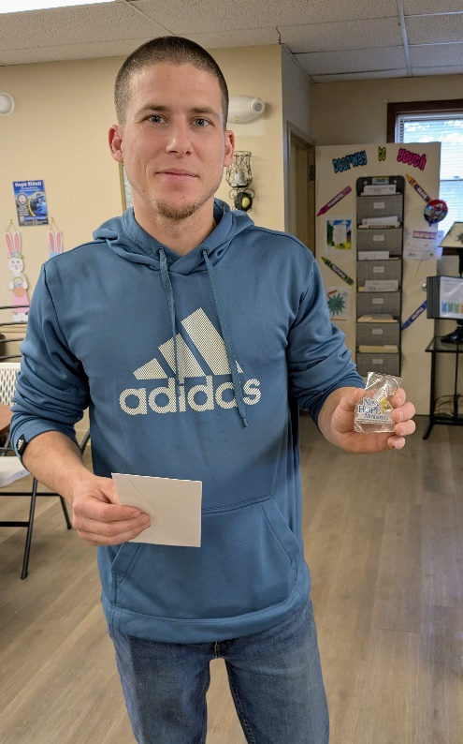

**Need help?** If you know someone needs help with food or dealing with a financial crisis, please contact us. (717) 432-2087

**Wish list:** We need personal care items at all centers! (Toilet paper, soap, shampoo, deodorant, feminine care products). [www.nhm-pa.org](http://www.nhm-pa.org)

**We could use your help!** Please prayerfully consider volunteering time at New Hope Ministries!

**www.nhm-pa.org**