Wrapping up Summer with Smiles!
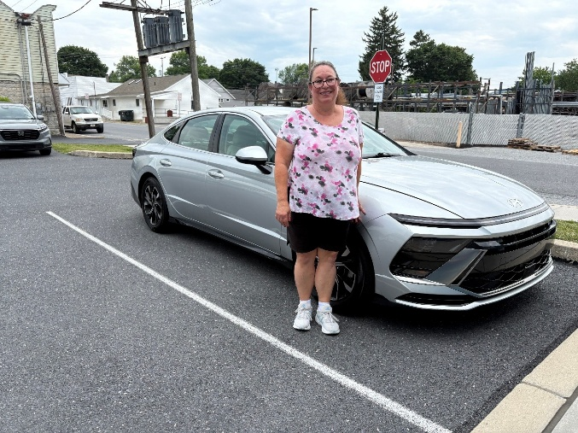
Summer may be coming to a close, but at New Hope, there is still plenty to smile about. Thanks to the continued generosity and support of our community, we are able to walk alongside our guests as they build brighter futures, just like Christine.
For the past 10 years, New Hope has had the privilege of supporting Christine on her journey toward stability and independence. Throughout that time, we have helped her secure housing, find employment, and cover critical car repairs. When her vehicle recently stopped working, New Hope's Car Loaner Program provided reliable transportation for two months, giving Christine the opportunity to save enough money to purchase her very first car.
Stories like Christine's are only possible because of compassionate supporters like you. Thank you for making lasting hope a reality for our guests!

Lord my God, I called to you for help,
and you healed me.
Psalms 30:2 (NIV)

Need help? If you know someone needs help with food or dealing with a financial crisis, please contact us. (717) 432-2087
Wish list: Please see website for specific needs by Center: www.nhm-pa.org
We could use your help! Please prayerfully consider volunteering time at New Hope Ministries!
www.nhm-pa.org

