

This Thanksgiving distribution, all nine New Hope Ministries centers were filled with energy, laughter, and the spirit of giving! Volunteers came together to pack thousands of complete turkey dinners, including turkeys, stuffing, gravy, and many other items, ensuring families in need could enjoy a warm, homemade meal with their loved ones.

We are deeply thankful to everyone who donated these items and to the volunteers who gave their time and hearts to make this day possible. Each act of generosity brought comfort, joy, and hope to our neighbors, reminding us of the power of community. and the difference we can make when we come together.

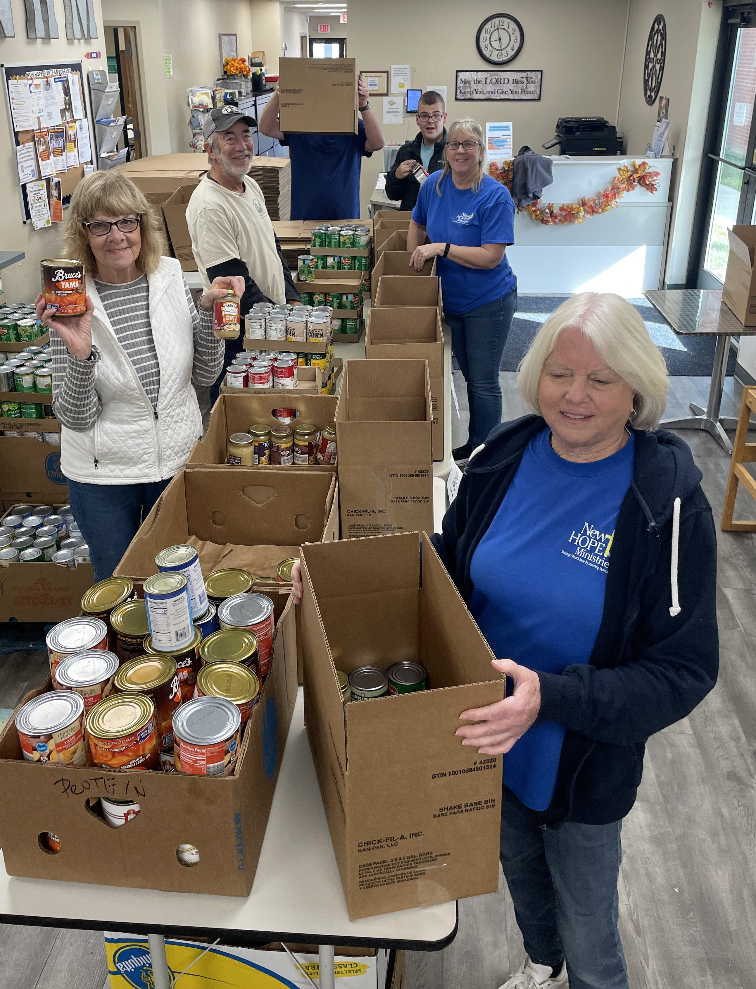Volunteer with us!
Christmas offers many new volunteer opportunities!
Check out the website for more details!
www.nhm-pa.org

Need Help?
If you or someone you know needs help
with food or dealing with a financial crisis,
please contact us.
(717) 432-2087

Wish List:
Canned goods
Pasta
Spaghetti sauce
Peanut butter
Cereal

