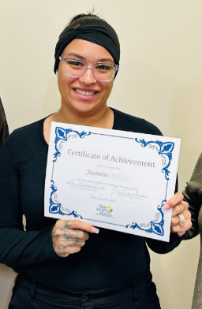

Meet Jasmine. She is a recent graduate of our preclinical class. Hope inspires not only her, but future generations as well. Upon completing the class, she shared with us, “...thank you for investing into not only my future, but my daughter’s future also, because now with this opportunity, I’m able to provide more for her and I can be a living testament that she can do whatever she sets her mind to do as long as she applies herself and works hard.”

At New Hope Ministries, seeing hope carry forward into the next generation is incredibly meaningful. Because of your belief in our guests, stories like this become possible. Thank you for helping create lasting change in our community.

Psalm 50:14
“Sacrifice thank offerings to God,
fulfill your vows to the Most High”

Need Help?
If you or someone you know needs help with food or dealing with a financial crisis, please contact us.
(717) 432-2087

Wish List:
• Canned meats and peanut butter
• Canned veggies/fruit
• Personal care items
• See website for specific needs by Center www.nhm-pa.org

Volunteer with us!
There are volunteer opportunities available. Please give us a call, or visit our website to see how you can be a part of our ministry!

