Summer Students, Thanks to You
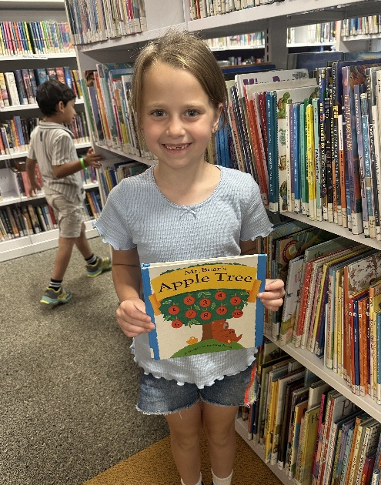
It’s the midst of summer, and thanks to your continued support, our Summer Youth Programs are thriving and making a lasting impact. These programs provide the young members of our community with a safe and welcoming place to grow, learn, and stay engaged during the summer months.
Through a blend of educational enrichment and meaningful connection, students are able to continue building important academic skills while also being encouraged in their faith and learning more about Jesus in a caring and supportive environment.
We are so grateful for your partnership in making this possible. Because of you, summer becomes more than just a break from school. It becomes a season of growth, discovery, and hope for every child who walks through our doors.

And God said, “Let there be light,” and there was light.
Genesis 1:3 (NIV)

Need help? If you know someone needs help with food or dealing with a financial crisis, please contact us. (717) 432-2087
Wish list: Please see website for specific needs by Center: www.nhm-pa.org
We could use your help! Please prayerfully consider volunteering time at New Hope Ministries!
www.nhm-pa.org

