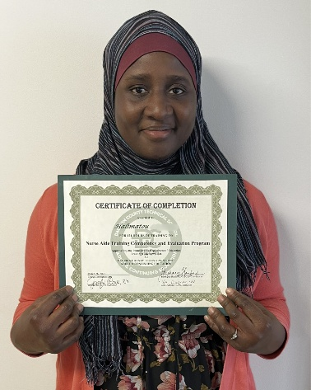
Kicking off the summer with success!
Halimatou came to New Hope Ministries back in 2024 seeking food services. The following year, she began asking about our Certified Nursing Assistant (CNA) program, and it quickly became clear that she was an exceptional student. She continued into our preclinical program, where she truly excelled every step of the way.
She started to study at Dauphin County Technical School in the evenings. Halimatou worked hard towards her goal and we are thrilled to share she recently passed both her state exam and her clinical exam! She even came back to show us her certificates, and we could not be more proud of her accomplishments.
Halimatou is now looking ahead to pursuing her LPN. When originally asked why she wanted to be a CNA she told us “This is my first step towards being a surgeon. When I was young, a surgeon took care of me and I will never forget it. I want to be a surgeon and this is a first step on that path.” We are extremely excited for Halimatou and all the amazing things we know she will accomplish.
John 3:17 (NIV)
For God did not send his Son into the world to condemn the world, but to save the world through him.

Need Help?
If you or someone you know needs help with food or dealing with a financial crisis, please contact us.
(717) 432-2087

Wish List:
• Canned meats and peanut butter
• Canned veggies/fruit
• Personal care items
• See website for specific needs by Center www.nhm-pa.org
Volunteer with us!
There are volunteer opportunities available. Please give us a call, or visit our website to see how you can be a part of our ministry!

