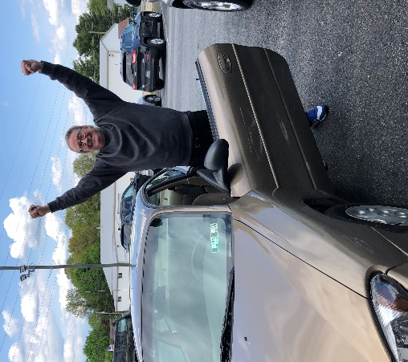

Did you know that many of the guests we serve are not only struggling with basic needs like food and housing assistance, but also need help with transportation? Having safe and reliable transportation is a necessity when getting to and from a job or other essential life demands. New this year, our program also provides basic instruction on how to care for vehicles to keep them running in their best condition. Pictured here is David who just received a vehicle from New Hope - he is overjoyed! Do you have a good-working vehicle to donate to New Hope? Please give Transportation Manager Michael Tichnell a call today to find out all the details! (717) 432-2087 x213.

Join us at our 40th Anniversary celebration at our Mechanicsburg Center, Tuesday, June 6, 2023 from 4:00-5:30pm

Join us at our 40th Anniversary celebration at our Hanover Center, Thursday, June 22, 2023 from 4:30-6:00pm

RSVP at nhm-pa.org

Need help? If you know someone needs help with food or dealing with a financial crisis, please contact us. (717) 432-2087
Wish list: Please see website for specific needs by Center: www.nhm-pa.org
We could use your help! Please prayerfully consider volunteering time at New Hope Ministries!
www.nhm-pa.org

