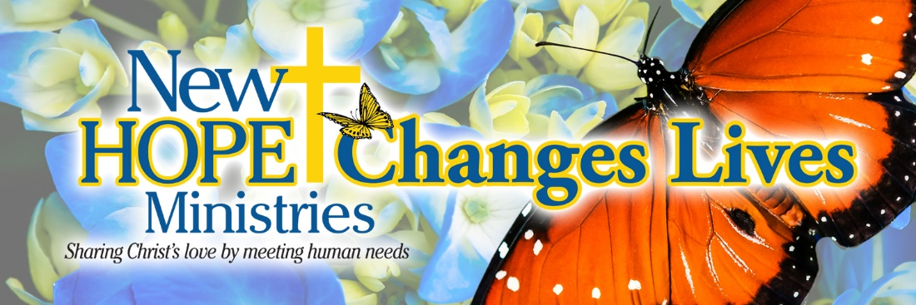

All of God’s grace in one little face.
Jade visited New Hope for the first time in January. She was having trouble making ends meet and needed help with heating her home during these cold months. She was very close to having her first baby and we provided her with a baby bundle. New Hope’s baby bundles are filled with everything a young mom would need for their new arrival – and it was a good thing we gave it to her when we did – baby Brooklyn arrived earlier than expected! Jade came to New Hope just looking for help with keeping her home warm and ended up receiving so much more! She found love, understanding and support.

Thank you for making these moments possible!

For we are God’s handiwork, created in Christ Jesus to do good works, which God prepared in advance for us to do.
Ephesians 2:10

Need help? If you know someone needs help with food or dealing with a financial crisis, please contact us. (717) 432-2087
Wish list: Please see website for specific needs by Center: www.nhm-pa.org
We could use your help! Please prayerfully consider volunteering time at New Hope Ministries!
www.nhm-pa.org

