From MAYday to Stability!
Tabitha came to us after her vehicle broke down, leaving her and her husband without reliable transportation to work. Through our Hope Rides program, she was able to borrow a car, keep working, and start saving.
With determination and support, Tabitha was able to purchase her own vehicle. Today, they have dependable transportation. We are grateful for the community whose generosity makes stories like this possible.
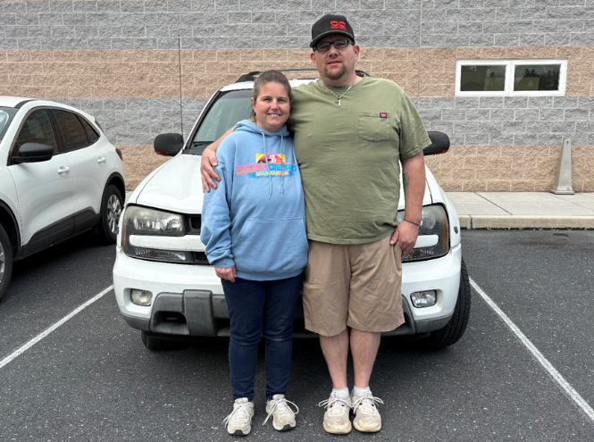
Philippians 1:9 (NIV)
And this is my prayer: that your love may abound more and more in knowledge and depth of insight,

Need Help?
If you or someone you know needs help with food or dealing with a financial crisis, please contact us.
(717) 432-2087
Wish List:
• Canned meats and peanut butter
• Canned veggies/fruit
• Personal care items
• See website for specific needs by Center

Volunteer with us!
There are volunteer opportunities available. Please give us a call, or visit our website to see how you can be a part of our ministry!

