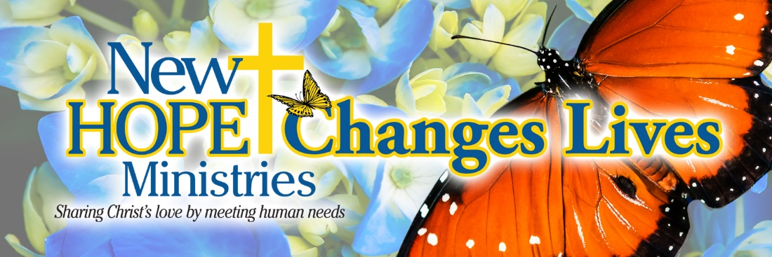

Did you know that at each of our nine center locations, we have a Reading Ready Corner with tons of children's books? Guests are encouraged to enjoy the books during their visit and take them home with the promise to bring them back so they can take a new one next time. It's like a mini New Hope library system for our kiddos. Mom Kimberlee and her daughters Kourtnnee and Kynzlee are among those who love visiting our Reading Ready Corner. Sweet Kourtnnee is literally "head over heels" for her book! We are grateful to the United Way of York County for providing the books for our Reading Ready Corners at our York County Centers. Thank you for supporting our programs and helping us create these special moments that will serve as a foundation for a lifetime of learning and literacy.

Jesus said, “Let the little children come to me, and do not hinder them, for the kingdom of heaven belongs to such as these.” Matthew 19:14 (NIV)

Need help? If you know someone needs help with food or dealing with a financial crisis, please contact us. (717) 432-2087
Wish list: Please see website for specific needs by Center: www.nhm-pa.org
We could use your help! Please prayerfully consider volunteering time at New Hope Ministries!
www.nhm-pa.org

