
At New Hope Ministries, loving hands are at work preparing hot, nutritious lunches for our guests in need. These meals are more than food, they’re an expression of God’s love and care, reminding each person who walks through our doors that they are seen, valued, and not alone. Along with our daily meal preparation, our food pantries provide families the opportunity to shop for groceries with dignity, choosing the items that best meet their needs. Whether it’s a warm meal shared in fellowship or a cart full of groceries to take home, we believe that feeding others is one of the most tangible ways to share hope. Your support keeps these vital programs going strong.
Together, we can continue to serve as the hands and feet of Christ, nourishing both body and soul in our community.
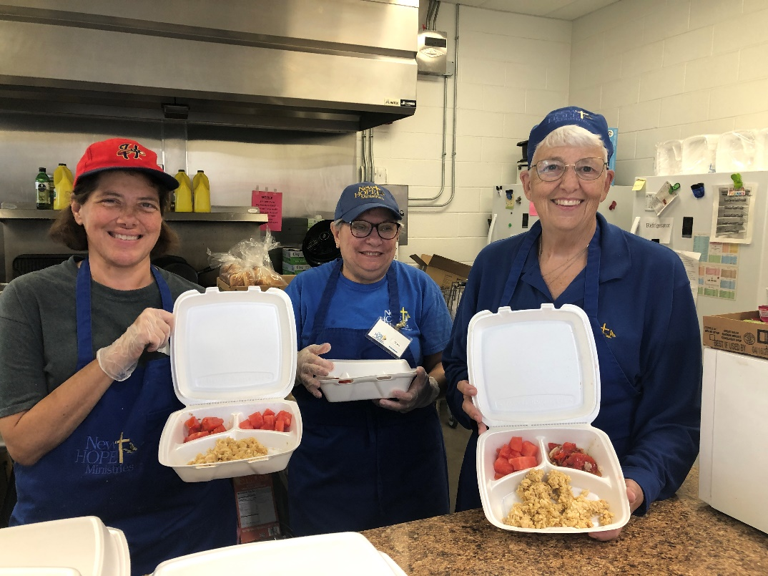

Need help? If you know someone needs help with food or dealing with a financial crisis, please contact us. (717) 432-2087
Wish list: We need personal care items at all centers! (Toilet paper, soap, shampoo, deodorant, feminine care products). www.nhm-pa.org
We could use your help! Please prayerfully consider volunteering time at New Hope Ministries!
www.nhm-pa.org

