Shelves Stocked Thanks to YOU!
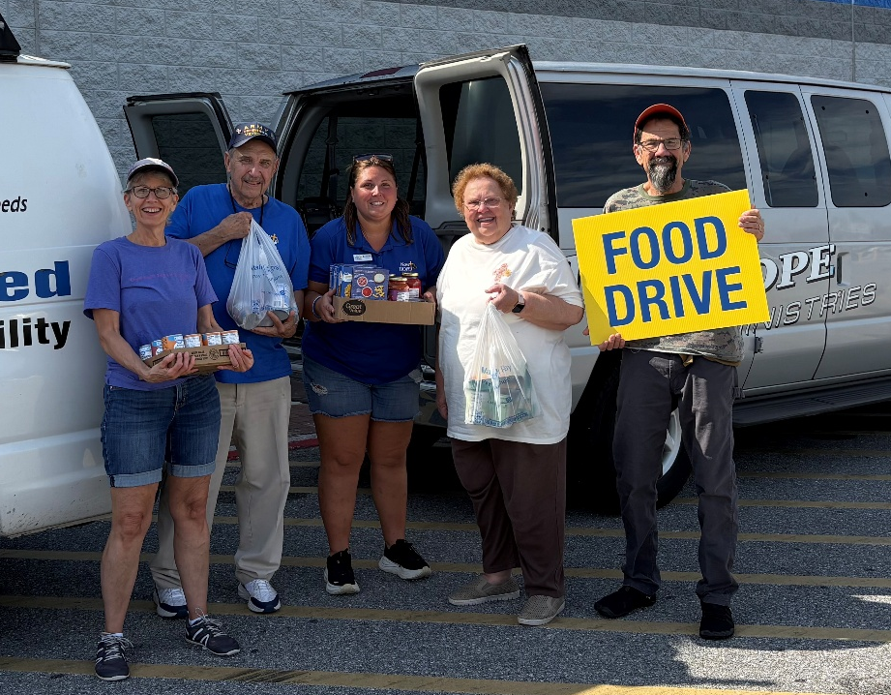
Our second Food For Hope Food Drive was an amazing reminder of what we can accomplish when our community comes together! Thanks to everyone who showed up and gave, we collected 22,717 pounds of food and $4,265.44 in financial donations!
These generous contributions will help keep our shelves stocked as we head into the holiday season and ensure we can continue supporting our neighbors in need.
We had a great time spending the day outdoors with our community and coming together to make a difference for our neighbors. Thank you to everyone who gave, volunteered, prayed, and supported this event. Your generosity made it a great success!

May the God of hope fill you with all joy and peace as you trust in him, so that you may overflow with hope by the power of the
Holy Spirit.

Romans 15:13 (NIV)

Need help? If you know someone needs help with food or dealing with a financial crisis, please contact us. (717) 432-2087
Wish list: Please see website for specific needs by Center: www.nhm-pa.org
We could use your help! Please prayerfully consider volunteering time at New Hope Ministries!
www.nhm-pa.org

