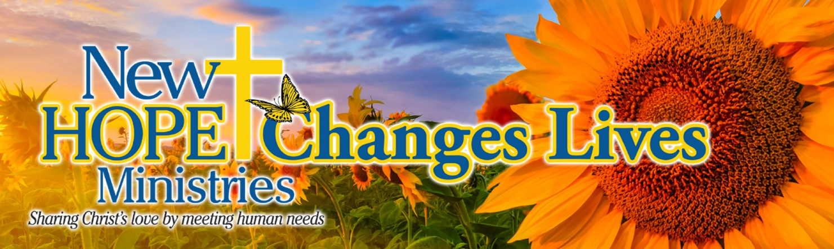

**Enjoy a sweet message we received from a guest of New Hope Ministries. It is because of YOUR amazing and loving support that we have these sentiments of love to share:**

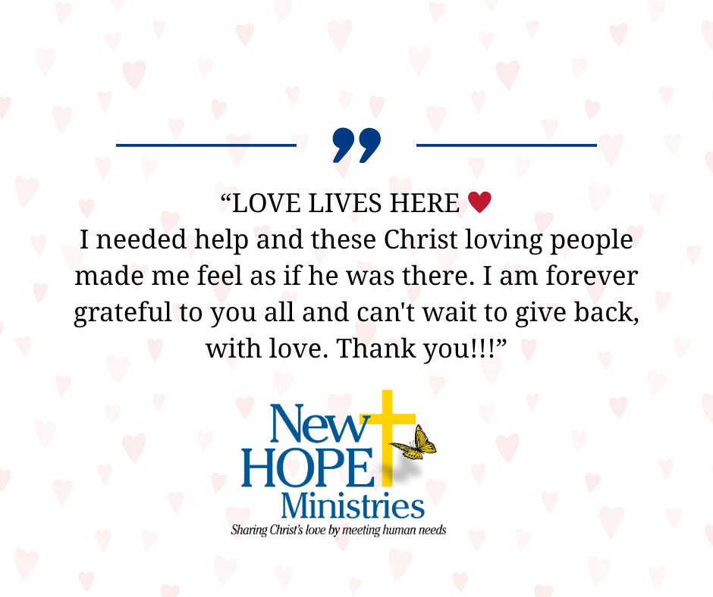

We are deeply grateful to our church community for your continued support and generosity. Your prayers, volunteer time, and contributions make it possible for New Hope Ministries to serve our neighbors in need every day.

 As soon as I pray, you answer me; you encourage me

by giving me strength. Psalm 138:3

**Need help?** If you know someone needs help with food or dealing with a financial crisis, please contact us. (717) 432-2087

**Wish list:** We need personal care items at all centers! (Toilet paper, soap, shampoo, deodorant, feminine care products). [www.nhm-pa.org](http://www.nhm-pa.org)

**We could use your help!** Please prayerfully consider volunteering time at New Hope Ministries!

**www.nhm-pa.org**