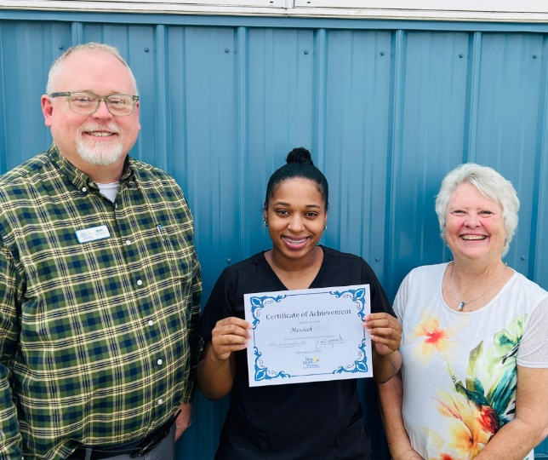
Found Support This Fall!
Messiah is a recent graduate of our pre-clinical program, and she shared with us how meaningful the support she received through New Hope has been. Without New Hope, she said she would still be trying to find her way. Instead, she found the support she needed and people who were willing to walk alongside her throughout her journey.
Through New Hope, Messiah also found community with others going through the program. Their encouragement helped remind her that she was not alone as she worked toward her goals.
Stories and accomplishments like Messiah’s are possible because of the incredible support of our community. By helping fund New Hope’s programs, you provide the resources and opportunities our neighbors need to move forward. Thank you for helping make stories like Messiah’s possible and for helping our neighbors find hope and a path toward sustainability.

So do not throw away your confidence;
it will be richly rewarded
Hebrews 10:35 (NIV)

Need help? If you know someone needs help with food or dealing with a financial crisis, please contact us. (717) 432-2087
Wish list: Please see website for specific needs by Center: www.nhm-pa.org
We could use your help! Please prayerfully consider volunteering time at New Hope Ministries!
www.nhm-pa.org

