Thanks to You, Back to School was a Blast!
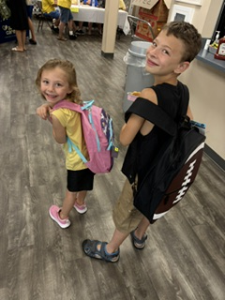
Throughout the summer, our generous supporters poured into our Back to School program, providing backpacks, pencils, notebooks, and other essential supplies for children in our community. At the beginning of August, our centers celebrated by placing these gifts into the hands of local students and families. For families already navigating financial challenges, your generosity helped ease the burden of preparing for a new school year while ensuring children had the tools they needed to feel prepared and confident.
The generosity of our community was felt across all of our centers as school supplies were donated in abundance. Children were filled with joy and excitement as they received their new backpacks and supplies and celebrated the start of a new school year. We are so grateful to everyone who gave and helped make this year’s Back to School program such a blessing.
Thank you for investing in the children and families who are the future of our communities!

Do not withhold good from those to whom it is due,
when it is in your power to act.
Proverbs 3:27 (NIV)

Need help? If you know someone needs help with food or dealing with a financial crisis, please contact us. (717) 432-2087
Wish list: Please see website for specific needs by Center: www.nhm-pa.org
We could use your help! Please prayerfully consider volunteering time at New Hope Ministries!
www.nhm-pa.org

